Discovering Patterns in Your Data:

Deep Learning vs Machine Learning

Visiopharm

Overview of AI, Machine Learning, and Deep Learning

At the beginning of computing, computers were very simple and only spat out answers to very low-level inputs. Now computers learn and act in ways that mimic human behavior that allow one to expedite data analysis and output. Any technique that enables computers to mimic human behavior are part of a broad spectrum of computer thinking known as Artificial Intelligence, or AI. As one goes deeper into the spectrum, AI advances and the computer learns without directly being programmed, in a process known as machine learning. The most advanced type of AI is known as deep learning, wherein the computer utilizes deep neural networks to learn the underlying features in data. This makes deep-learning particularly suited for training computers to recognize objects of interest in images to automate pathology image analysis in even highly heterogenous images for quick turnover of large caseloads. While machine learning and deep learning are part of the AI spectrum, not all AI uses machine learning and, likewise, not all machine learning processes utilize deep learning.

Artificial Intelligence

The term AI encompasses any technique that enables computers to act like humans.learning, AI can be as basic and simple as acting on a series of if/and/then statements. Any computer can be programmed to accept data from sensors or input and cause a specific output to then happen, i.e. if A and B happen, then C happens. In this capacity, AI does not learn, it only follows orders.

As an example, if we have an image where the tumors are distinguished by dark stains relative to the rest of the image, we can easily program the computer to recognize shapes above a certain threshold, i.e. their darkness. In this capacity, the computer searches for objects that are darker and excludes all other content. The parameters are made by the user and do not change based on new information. Thus, if the pathology of the tumors change or the staining changes, the user must reprogram the computer to recognize them.

Machine Learning

Conversely, machine learning is the ability to learn without being programmed. This is done by filtering input from multiple sources into an additional series of parameters, known as a hidden layer, that further classify the data into set categories that then trigger a set response. In this regard, the computer can classify inputs to make decisions based on multiple parameters or thresholds, allowing it to learn albeit in a limited capacity.

If we were to apply this type of learning to a pathology image, we would expect it to be more useful in cases that require multiple classifications of objects. For example, tissue samples with discolored tumor regions stained on glass. If one wanted to analyze the tissue and tumors they would need to separately examine each one and exclude the glass. Thus, the user programs a parameter to recognize the tissue and distinguish the tumor from the glass, using color or darkness for example. A machine learning system to search the image for the tissue and exclude the glass before then searching the tissue images for the characteristics that would match the tumor parameter. Therefore, the computer learns what is tissue from glass and only looks for tumors within the tissue without needing to be reprogrammed. However, it is still working on defined parameters and must be reprogrammed if any change.

Deep Learning

Deep learning further builds on machine learning to learn the underlying features in data using deep neural networks. A deep neural network uses multiple hidden layers based on multiple inputs. From these inputs, the computer can continually and iteratively redefine parameters based on how it processed previous inputs, allowing it to effectively learn how to process new data based on its own learning of the previous data.

Deep learning is the most complex and accurate form of AI but also the one that requires the most time to train. It is best used in highly heterogenous images where morphology plays a role. For example, in cell stains where subtle changes in morphology distinguish objects of interest, a computer equipped with a deep learning system searches through the image to find objects with different morphology relative to surrounding objects. The computer then uses these objects to distinguish more objects based on how similar they are to the previous images, allowing it to even adjust to minor variations. With deep learning, computers not only change the rules they use to distinguish objects but also the parameters on which the rules are based, creating a deep analysis that most resembles human thinking.

So how does AI get applied to image analysis? Visiopharm’s tissue analysis software has the flexibility to employ classifiers that utilize AI, machine learning, and deep learning depending on the analysis needs. But why AI? Pathology is both complex and variable. Pathologists train to recognize these complex variations and this training is not easy to translate into programmed commands. Therefore, we need AI that can act like a human brain to analyze these images.

Visiopharm’s Classifiers

Visiopharm utilizes five classifiers to analyze images: threshold, Bayesian, decision forest, K-means clustering, and deep learning. These methods are classifications of image regions which postprocessing may then be applied. Parameters are user-defined thresholds that are used by classifiers to distinguish regions of the images as objects for further processing.

Threshold

Threshold classification uses the values attributed to the pixels of an image to separate objects based on their values being over a certain threshold (see Figure 1). The threshold must be defined by the user, and output is based on the outcome of if/and/then statements. As each object is assessed only to verify that each pixel is above a threshold, no learning or deeper processing of the information is performed (see Figure 2). Therefore, threshold classification is not robust and will only work on a set of very similar images.

Figure 1. Threshold classification. Left: Each pixel in an image is evaluated for intensity above a specified threshold. Right: Sample images with threshold classifier applied. Only the white portions of the images are evaluated to be above the threshold. The rest of the image is not above the threshold and is darkened.

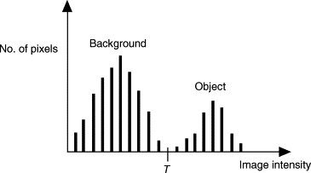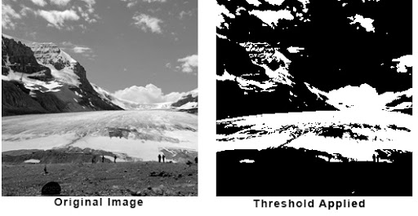

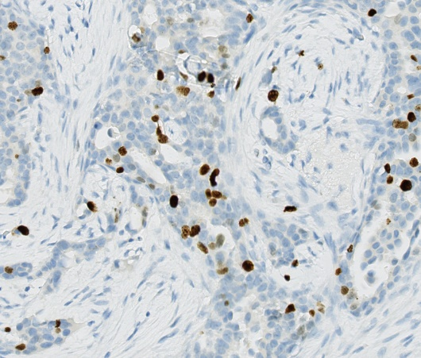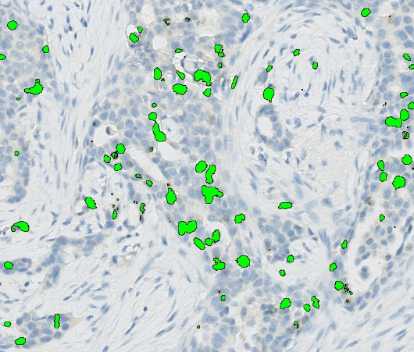

Figure 2. Threshold classification of cells. Left: An image of cells is evaluated by threshold classification. Right: The green highlights those cells registered to be above the threshold of intensity and classifies them as objects for analysis.

Machine Learning Classifiers

Machine learning generally encompasses three of the classifiers: Bayesian, Decision forest, and K-means clustering.

Bayesian probability, based on Bayes’ Theorem, computes and updates probabilities after obtaining new data. Bayes' theorem describes the conditional probability of an event based on data as well as prior information or beliefs about the event or conditions related to the event. In this regard, Bayesian classifiers must have supervised input to learn how to define prior information.

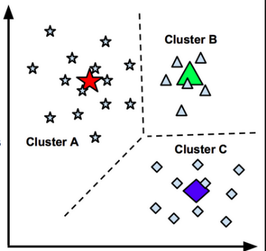

Decision forest learning is a predictive modelling approach that uses a decision tree (as a predictive model) to go from observations about an item (represented in the branches) to conclusions about the item's target value (represented in the leaves). Decision forest learning must be supervised to define each item.

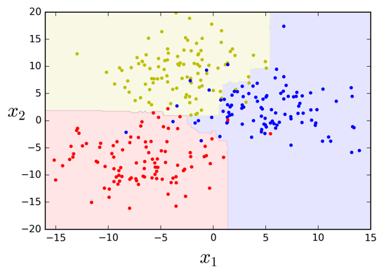 Lastly, K-means clustering partitions observations into *k* clusters in which each observation belongs to the cluster with the nearest mean. K-means clustering may be supervised, requiring user input to assign objects to certain clusters for better learning, or unsupervised, allowing the software to make decisions on how each observation is placed into each cluster.

Regardless of the classifier, each classification method uses user-defined features to distinguish groups of pixels in an image into distinctive classes that may be used to differentiate objects. Additionally, each may be trained by user input to automatically distinguish pixels into appropriate object categories. As each feature does not address new information based on how old information is processed, all features are considered machine learning and do not go deep enough to be considered deep learning.

Deep Learning as a Classifier

Deep learning is the final classifier that Visiopharm uses in their image analyses. Unlike machine learning, which uses a singular hidden layer to process inputs, deep learning utilizes two or more hidden layers in a deep neural network (see Figure 3).

Figure 3. Non-deep vs. Deep Neural Networks. In non-deep neural networks (i.e. Machine Learning), inputs are filtered through one set of parameters that further categorizes information. In a deep neural network, multiple series of parameters process data from the input and each subsequent hidden layer to create new outcomes.

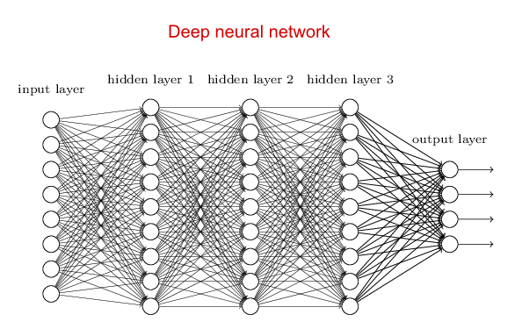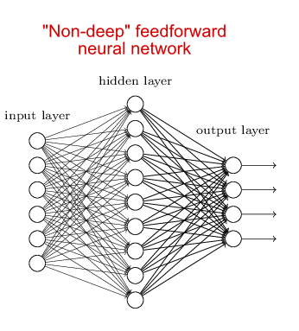

Deep learning is distinct from machine learning in that it can adapt to new circumstances based on previous information that it has processed. In this regard, deep learning can be “trained” to recognize new objects based on how it has previously analyzed similar objects. This training is known as representational learning, where inputs are given that define desired outcomes and the computer uses these representative inputs to further define and classify objects based on those given in an iterative learning process. Thus, deep learning can be trained to be much more dynamic than any previous classifier.

Choosing the Right Classifier

Considerations

When choosing the correct classifier to analyze images, there are things to consider. Having many different pixel/object classes will overcomplicate simpler AI-based classifiers. Likewise, if there are preanalytical variables (such as artifacts, differences in staining intensity, etc.) then that will impact the choice of classifier as well.

One of the main barriers to some classifiers are if the objects to classify are not easily distinguishable. For example, staining techniques like immunohistochemistry, in-situ hybridization (both bright-field and fluorescent, or other special stains allow one to distinguish the pixel/object more easily by eye, which will in turn allow for easier readability by most classifiers. If objects cannot be clearly distinguished by eye, then most classifiers will also have difficulty distinguishing those pixels/objects. Analysis reliant on morphology of an object can likewise be difficult for most classifiers to distinguish from background.

Lastly, time constraints must also be considered when choosing classifiers. Machine learning and deep learning classifiers take longer to train the software to appropriately distinguish objects, but may result in more accurate and robust analyses of complex images. If time is a constraint, the simpler AI and machine learning classifiers would be preferable though pre-trained apps are also available.

With these considerations in mind, let us now look at examples of image analysis one might be expected to perform. For each, we will take into account the goal, the parameters one must consider, and the best classifier to use for each:

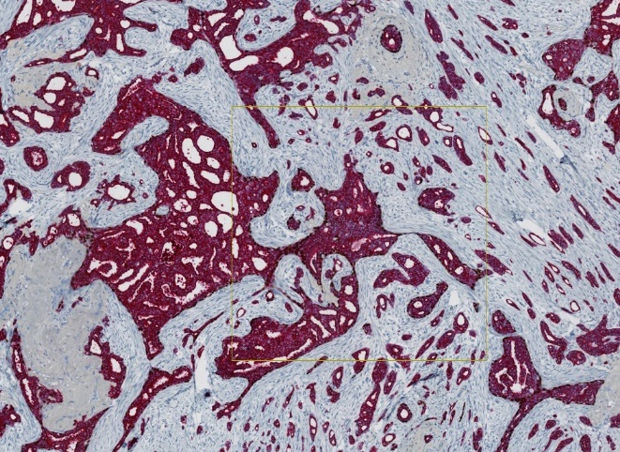First example: Identifying positive- and negative-stained areas, excluding glass

In this example, the goal is to establish the % CK7/19+ area (darkly stained cells) from this image of stained cells. To do this, CK7/19+ area, CK7/19- area, and the glass must all be identified and sorted appropriately into 3 classes or categories. As the staining is consistent and the sample homogenous, no pre-analytical variables need to be considered. Likewise, the classes are contrasted by color, distinguishable by eye, and not reliant on morphology. In this case, threshold, Bayesian, decision forest, and K-means are all acceptable classifiers to immediately obtain results (see Figure 5).

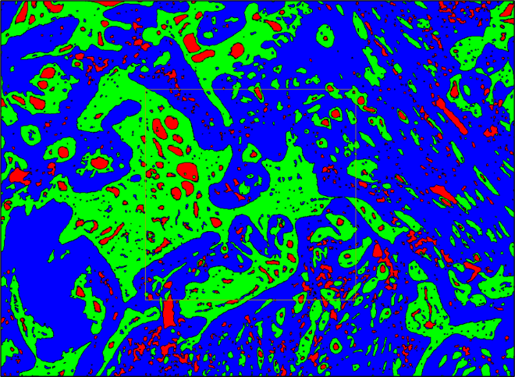

Figure 5. Same image with threshold classifier applied. Despite its simplicity, threshold can clearly distinguish each class for analysis.

Second example: Identifying areas of tumor within a tissue sample

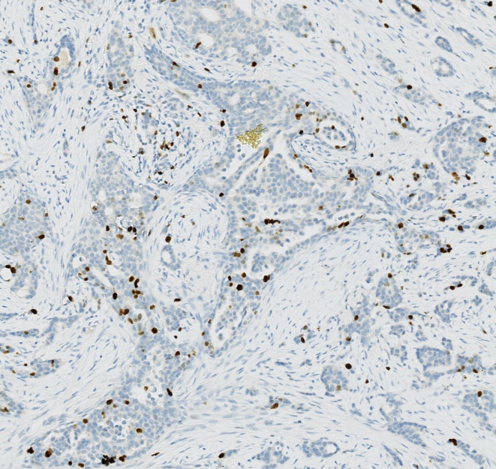

This last example calls for identifying the areas of the tumor and the areas of normal tissue within a sample. While there are only two classes, the sample is highly heterogenous and heavily reliant on morphology for classification. While cells and tumors can be distinguished by eye, there is no clear color contrast distinguishing the classes. Thus, a trained deep learning system is best used here to distinguish the tumor from sample (see Figure 6). Deep learning is best used when samples have high heterogeneity or rely on morphology for identification. Deep learning is accurate but requires time to learn the object classifications.

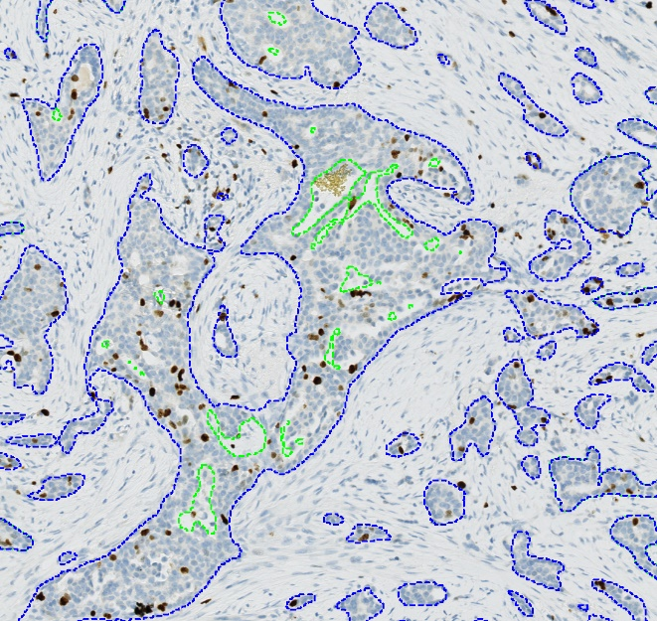

Figure 6. Same image applied with deep learning classifier. Tumor and sample objects will need to be trained by user input to accurately distinguish the two. This process is long but will accurately classify all objects.

Summary

Thresholding is one of the easiest classifiers to use and gives ultimate control but relies on advanced development of features to become as robust as the machine learning classifiers (except deep learning). It is best when there is high contrast between objects that does not rely on morphometry and a result is needed faster than the time it would take to train a deep learning classifier. However, it can only be used a small data set with low variability.

The remaining machine learning classifiers (Bayesian, Decision Forest, and K-means) can quickly tackle most image analysis tasks, and each has their slight advantage. Machine learning classifiers are best used for quick APP development when contrast between objects being classified is high.

Deep learning can be used to classify nearly everything, but it requires developing a robust training set and time to learn. Deep learning is best used when morphometry is a key differentiator and/or the study has high heterogeneity in either disease or preanalytical variables.

Here we discussed the differences in the types of AI classifiers. To learn more about applying them to images, take a look at our next white paper and learn more about Visiopharm’s image analysis solutions at visiopharm.com.