Visiopharm

Examining the digital pathology of tumor blood vessels

Blood vessels are responsible for bringing oxygen and nutrients to every cell in the body while removing waste and contributing to the spread of immune cells. However, in most types of tumors, new blood vessels produced through angiogenesis have abnormal structure and function which lead to impaired perfusion. Understanding these morphologies is essential to find new vulnerabilities that can be targeted to fight tumors. Here we look at how one study looks at the microanatomy, morphology, and function of blood vessels in tumors using digital pathology to simplify and expedite the process.

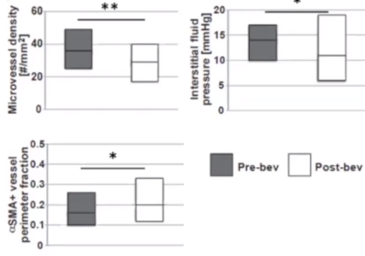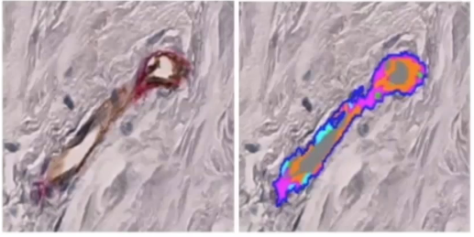Dr. Giorgio Seano at the Institut Curie Research Center looked at the digital pathology of tumor blood vessels in two different contexts. In the first, he looked at the effects of the drug Bevacizumab on normalizing blood vessels in metastatic breast cancer in the context of improving clinical outcome. Metastatic breast cancer, like most other tumors, produces abnormal blood vessels that lead to hypoxic conditions, creating malignant conditions for the surrounding tissue.

Images were taken from patient samples of the affected tumor blood vessels before and after treatment with Bevacizumab. These images were subjected to Visiopharm software that automatically scanned and selected for the tumor tissue, blood vessels, and coverage based on the stains used for imaging. Manual refinements of the labels created output quantifications that were graphed using in-software methods, allowing for the quantifiable comparison of blood vessels from before and after treatment. They found that in tumors with high microvascular density treatment with Bevacizumab created a high extent of normalization in responders that improved perfusion and reduced malignancy.

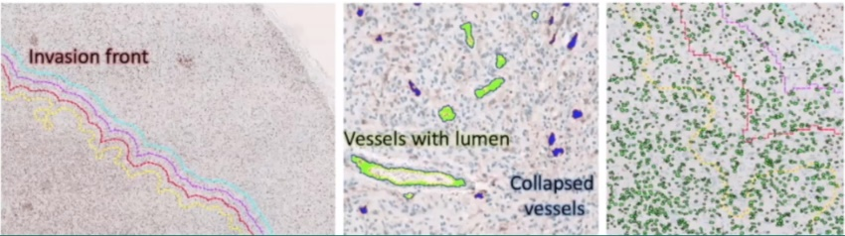In the second context of using digital pathology to explore tumor microenvironments, researchers looked at the timeline of glioblastoma cells co-opting existing blood vessels. When a vessel is co-opted, tumor cells develop along pre-existing vasculature, facilitating their spread. Images of the tumor microenvironment were generated using patient-derived cell lines in mice and stained for biomarkers representing tumor nuclei, blood vessels, and the tumor border. Visiopharm software automatically distinguished each of the three biomarkers and classified the tumor invasion front in each group of blood vessels. These classifications were then used to compare tumor co-opting over time.

Here we have looked at two cases where the digital pathology of tumor blood vessels was investigated using Visiopharm software to automate and simplify interpretation. For a more in-depth look at these studies and how Visiopharm was used to generate digital pathologies, view this webinar featuring Dr. Giorgio Seano: <https://visiopharm.wistia.com/medias/essgiogibo>.